**Course Name:   
Web Application Development  
(CPRG-008-004)**

**Instructor:** Ali Khalil

**Assignments 1-6**

**Date:** July 31, 2021

**Student Name:** Fariha Siddiqui

**ASSIGNMENT 1:**

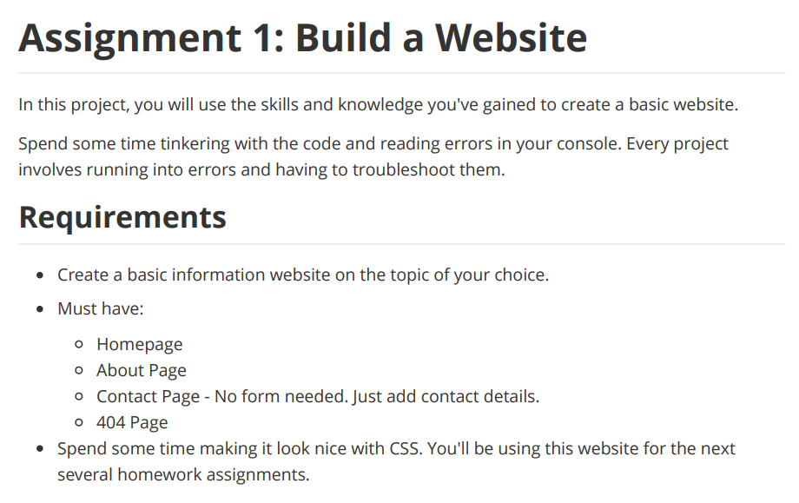

This section describes the different interfaces for the online travel-agency website. It contains a detailed description about each interface along with a screen shot of the interface.

1. **Home Page:** The main page of the website which is common to all visitors. Link to home page is available throughout the website via Company logo. It includes:

* A navigation panel,
* Travel Packages available,
* Random Greeting to the visitor, and
* Day of the week.

Each navigation item links to an individual page containing items related to that page.

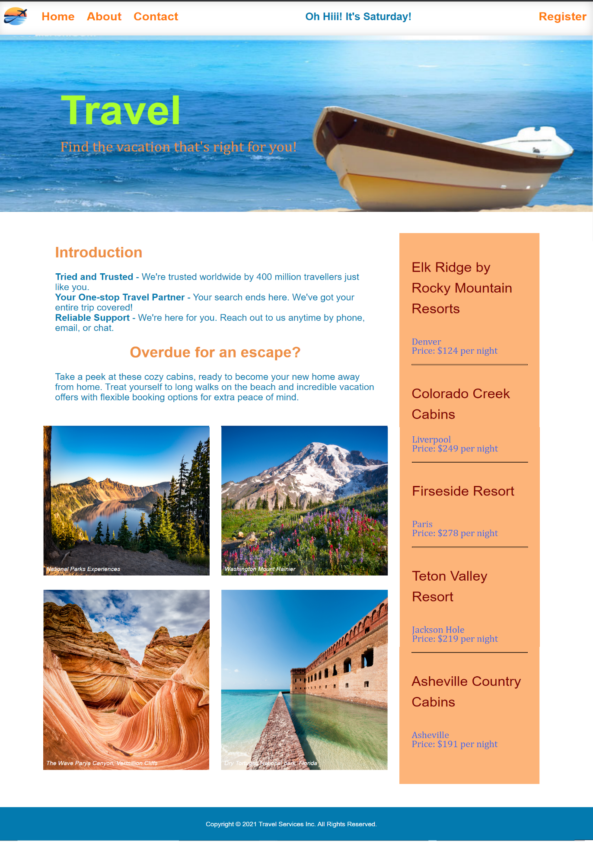

1. **About Page:** This page gives visitors an insight into the purpose of the organization and the people behind it. This includes:

* History of Travel Agency organization,
* What makes the Travel Agency unique,
* What are the organization's values and beliefs, and
* Why customers should choose them.

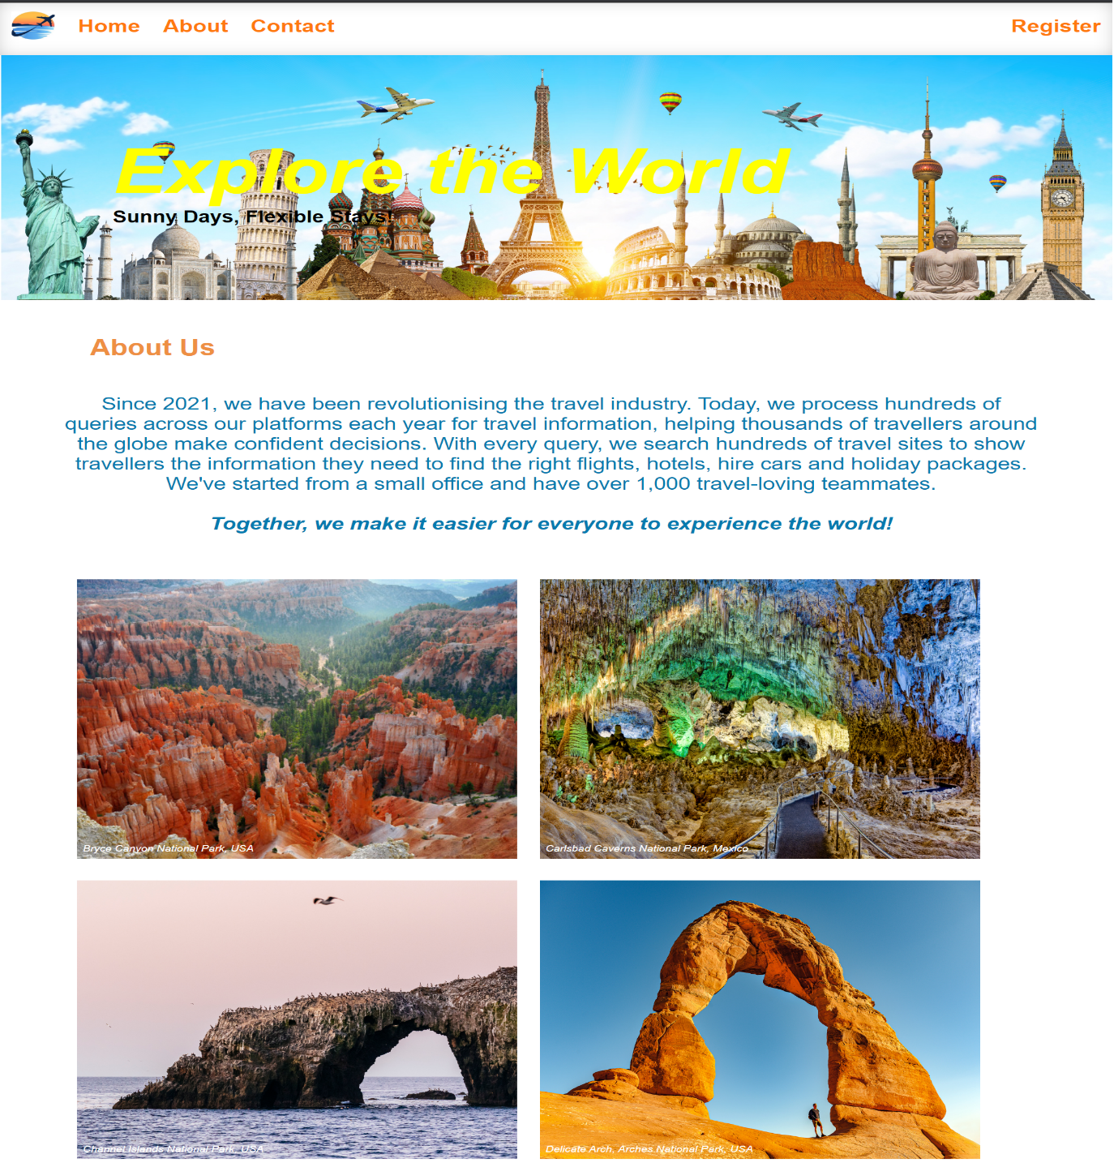

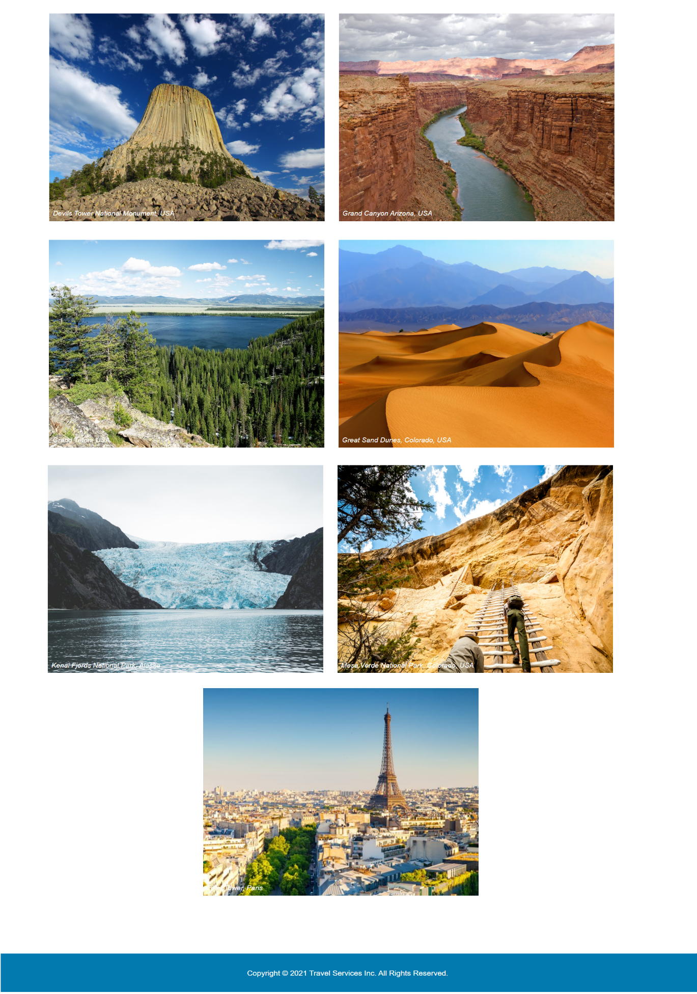

1. **Contact Page:** This page on the website allows visitors to communicate with the Travel Agency for any question or concerns.

The Contact page has a Contact Form containing fields for filling in First Name, Last Name, Email Address and Comment / Questions. The form provides an immediate, convenient way for visitors to reach out to the Travel Agency for any questions or comments or clarifications.

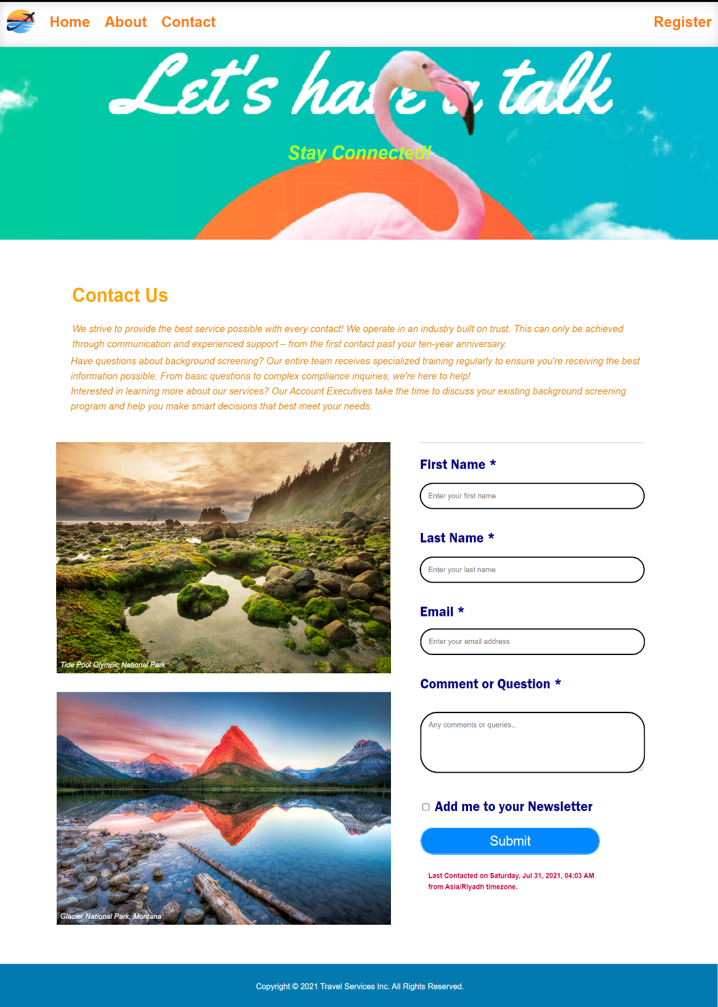

1. **404 Page:** This page indicates that the webpage you're trying to reach cannot be found. This could be encountered for one of the following reasons:

* A problem with the web application,
* The page you are looking for was moved or deleted,
* The typed URL was wrong,
* A server error encountered.

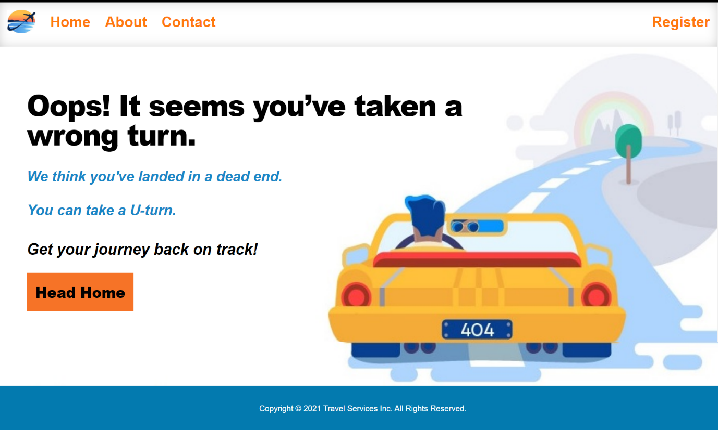

1. **Register Page:** This page on the application is to allow visitors to register with the Travel Agency to create an account and access more services. The Register page has a Registration Form containing fields for filling in First Name, Last Name, Email Address and a Password, that the users will use to log in.

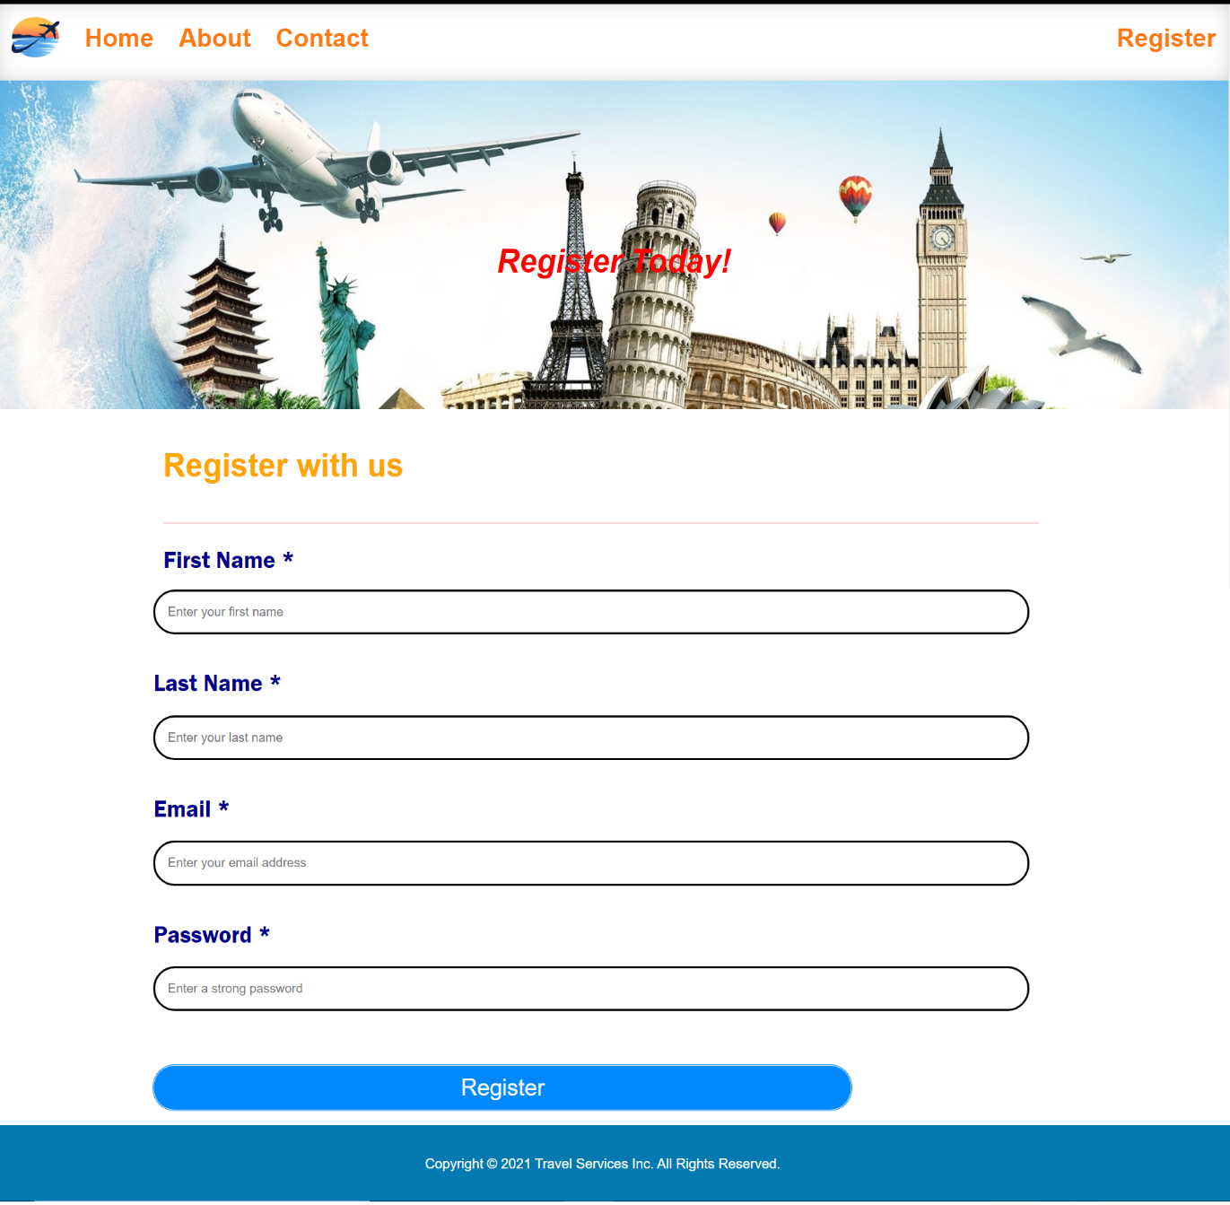

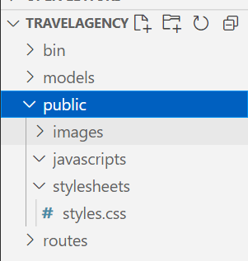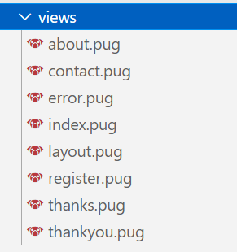Cascading Styles (CSS) and Images related to all the pages have been defined in public folder. Pug templates have been used for building the front-end.

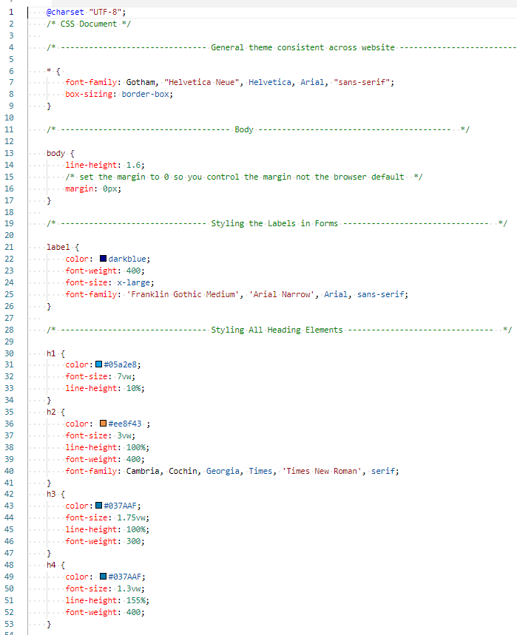

**ASSIGNMENT 2:**

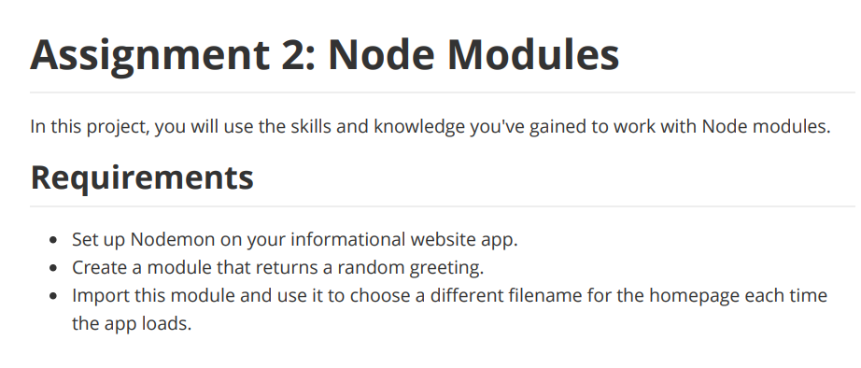

1. To accomplish the above, create a Folder.
2. Create an index.js file within the folder.
3. Make sure that you have navigated to this folder in VS Code Terminal.
4. Add: **console.log("Working...")** index.js file and save.
5. Setup Nodemon, by initializing npm, with the following command in VS Code Terminal: **npm init**
6. Follow the prompts that VS Code Terminal takes you through and answer all the questions.
7. To install nodemon, enter in the Terminal:  
    **npm i nodemon --save-dev**
8. Update your "start" script in pacakge.json file. In scripts section, replace the "test" line with: **“start”: “nodemon myfile.js”.**
9. Once console logs working and the installations are successful, restart the Terminal, and install Random Greetings module, by giving the command in Terminal:  
    **npm i random-greetings**
10. Test by giving the command in Terminal: **npm start**
11. This module returns random greetings that can be saved in a variable and passed to index pug file for displaying it on Home page, as shown below:

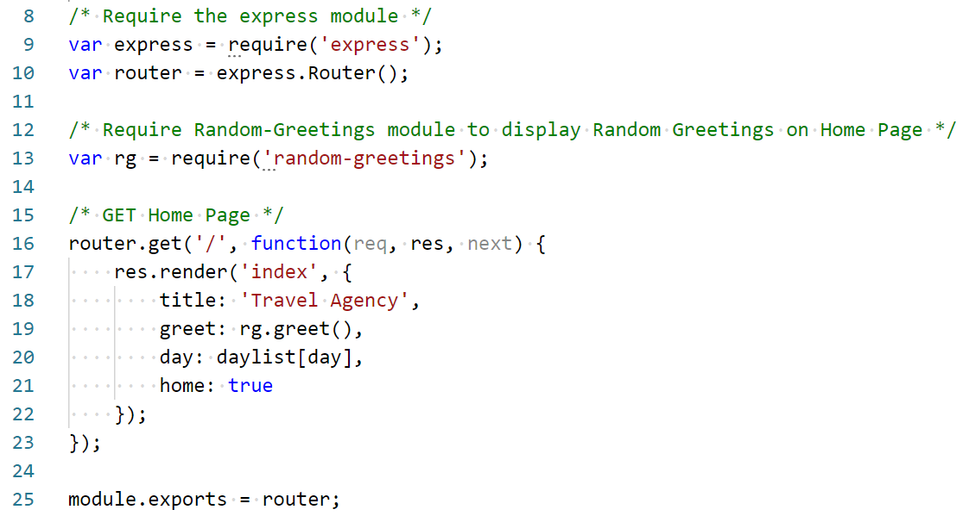

The module generates a random greeting every time the Home page loads.



  
   


**ASSIGNMENT 3:**

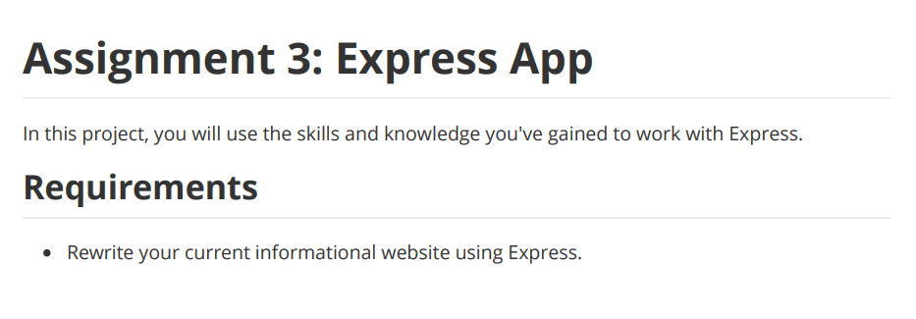

1. To accomplish the above, initialize **npm**.
2. Install **nodemon**.
3. Update **'start'** script.
4. Install express by entering the following command in the Terminal:  
    **npm install express**
5. Check dependencies in package.json file to confirm successful installation of express in your project:

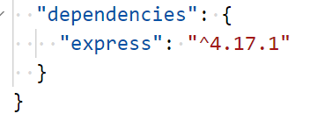

1. Require the module and utilize its functions as needed, for example, listening to requests on different ports, etc.

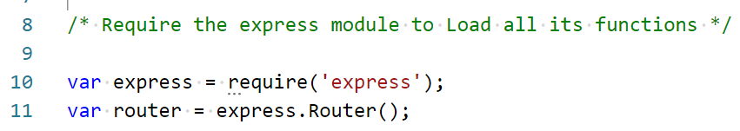

**ASSIGNMENT 4:**

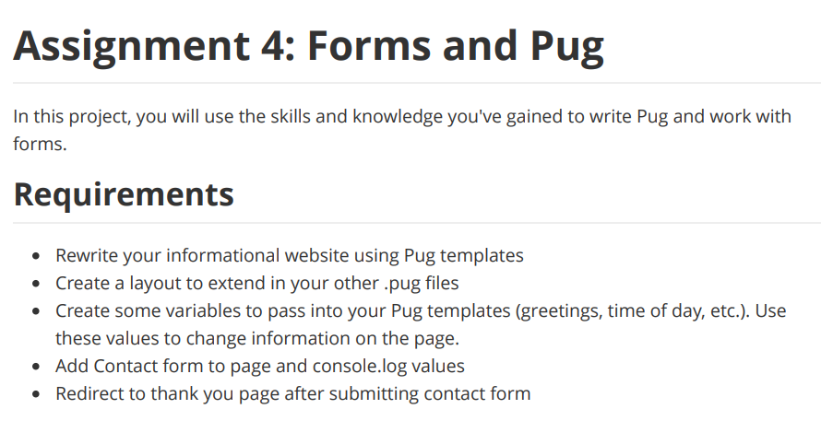

**PUG Template Engine** helps us in creating HTML content dynamically. Express JS by default uses PUG Template Engine.

To accomplish the above, install pug by following the steps below:

1. Install express by entering the following command in Terminal:  
    **npm install express**
2. Install pug by entering the following command in Terminal:  
    **npm install pug**
3. Start your code by giving the following command in Terminal:

**npm start**

1. Check dependencies in package.json file to confirm successful installation of express and pug in your project:

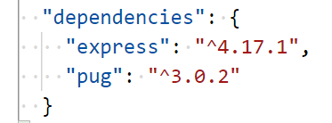

**All pages of the website have been written using pug templates.**

1. **HOME PAGE** – Index.pug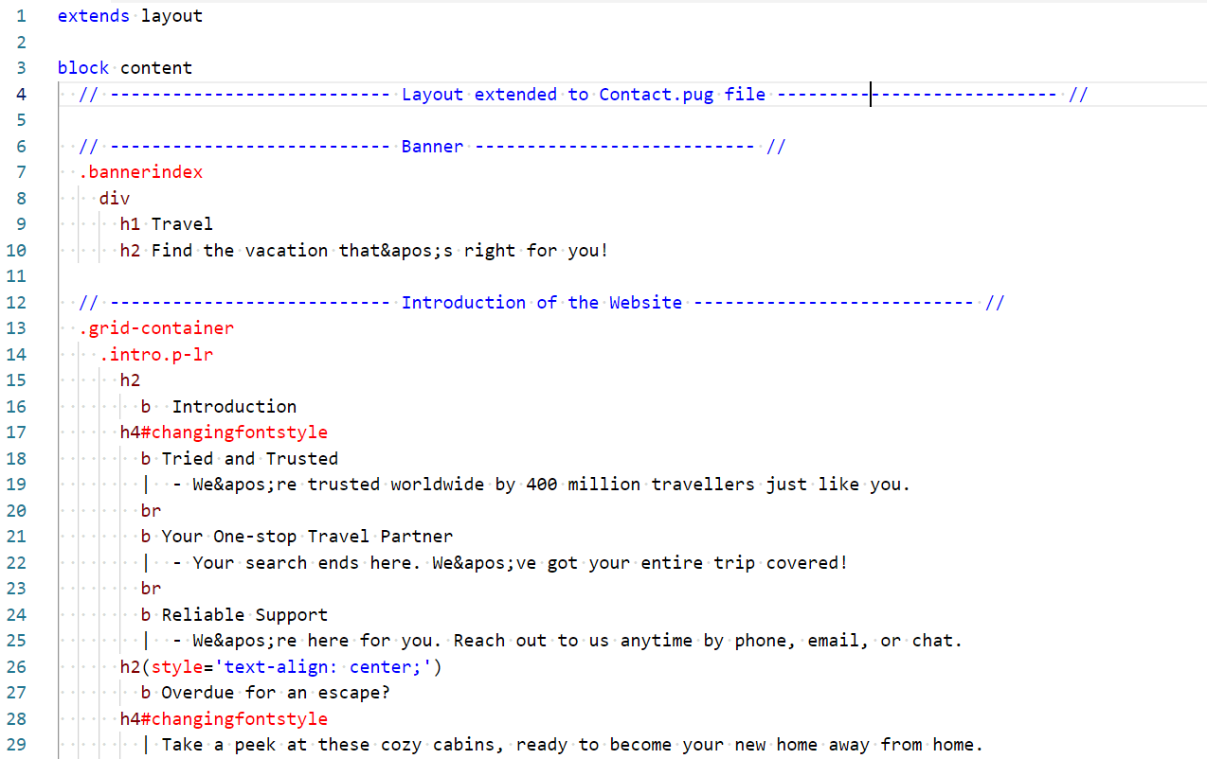

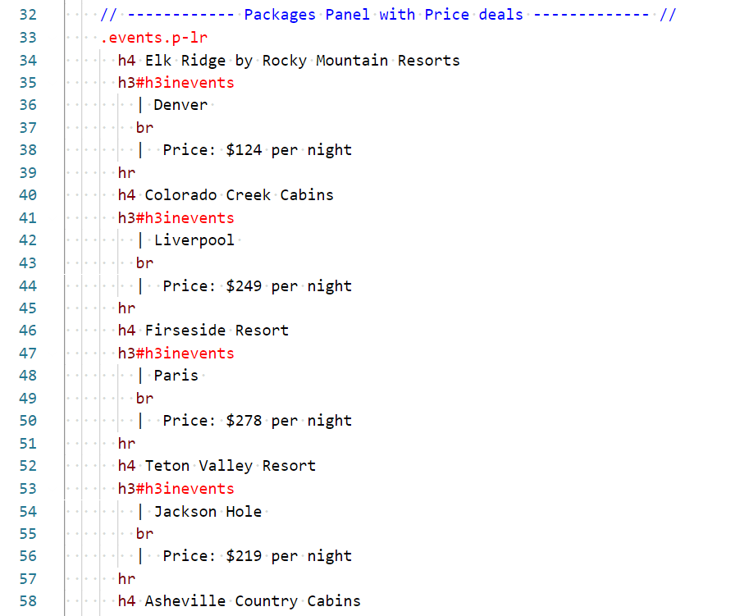

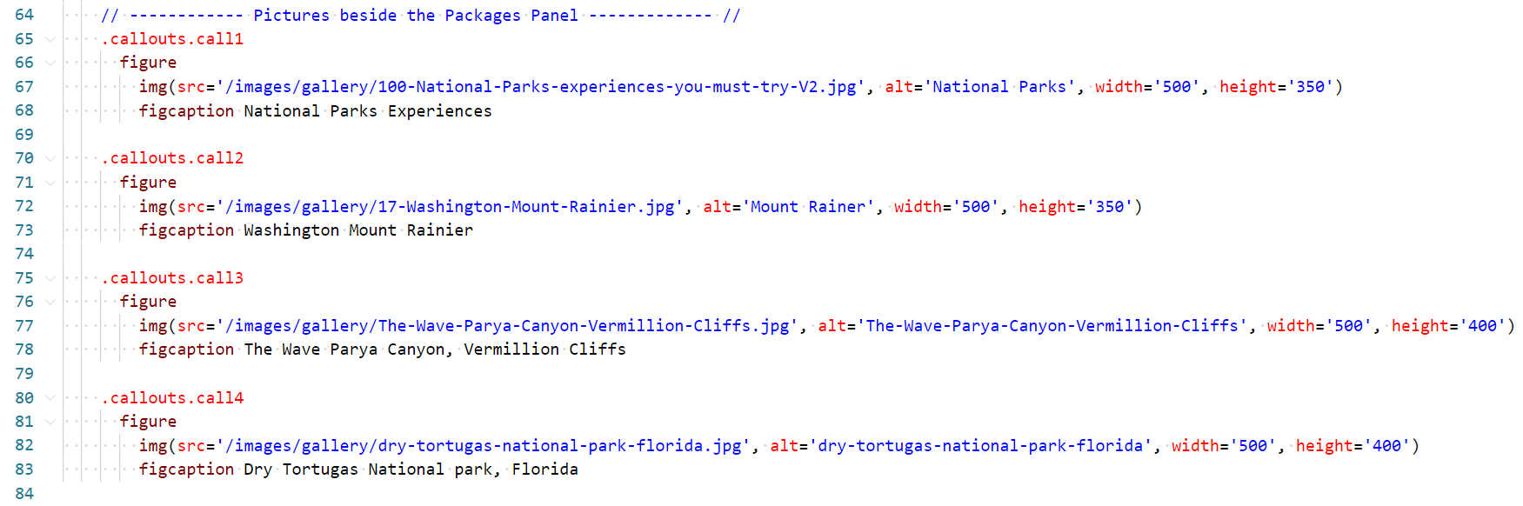

1. **ABOUT PAGE** – About.pug

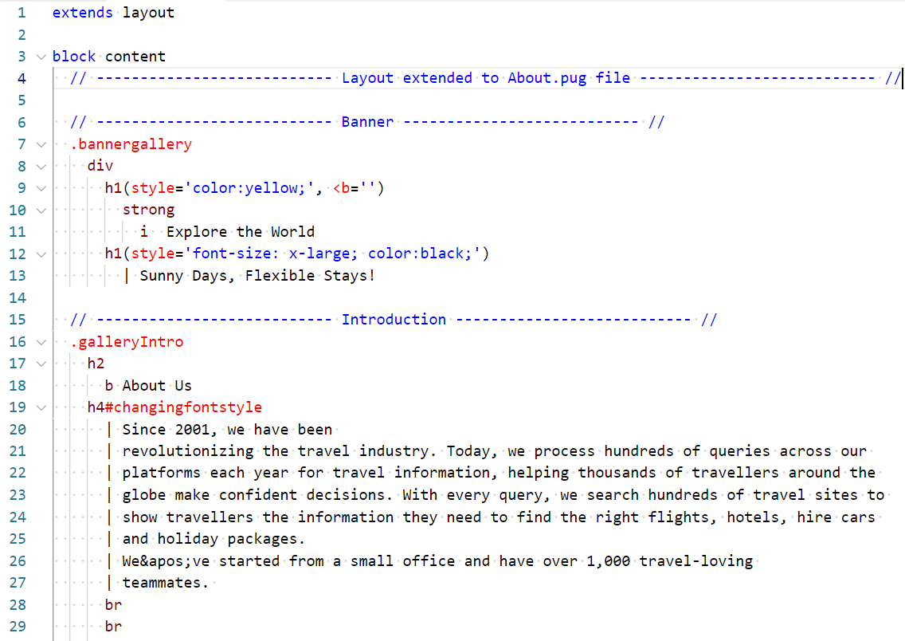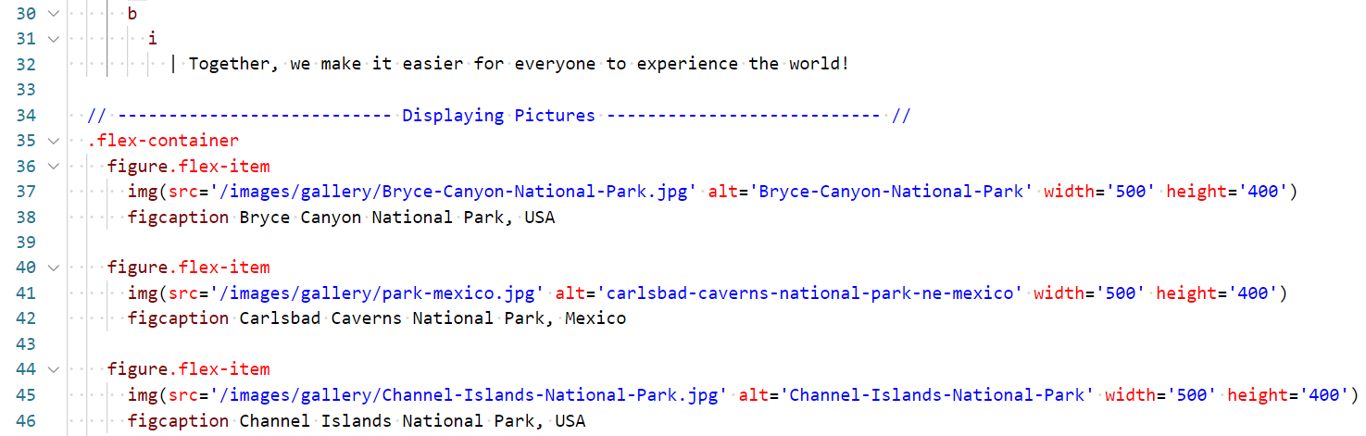

1. **CONTACT PAGE** – Contact.pug

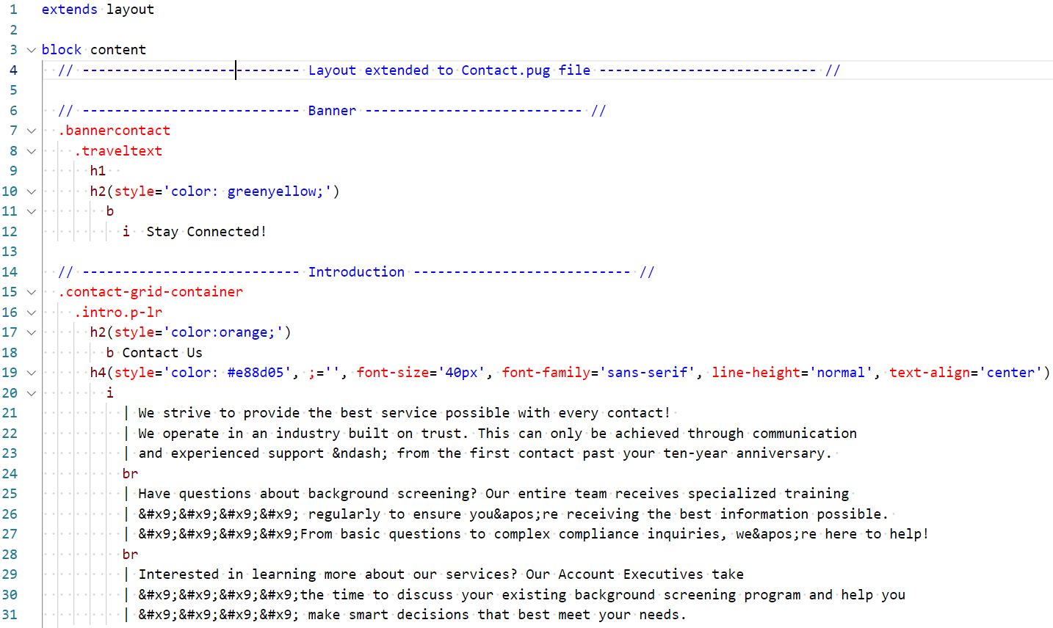

**CONTACT FORM added to Contact page:**

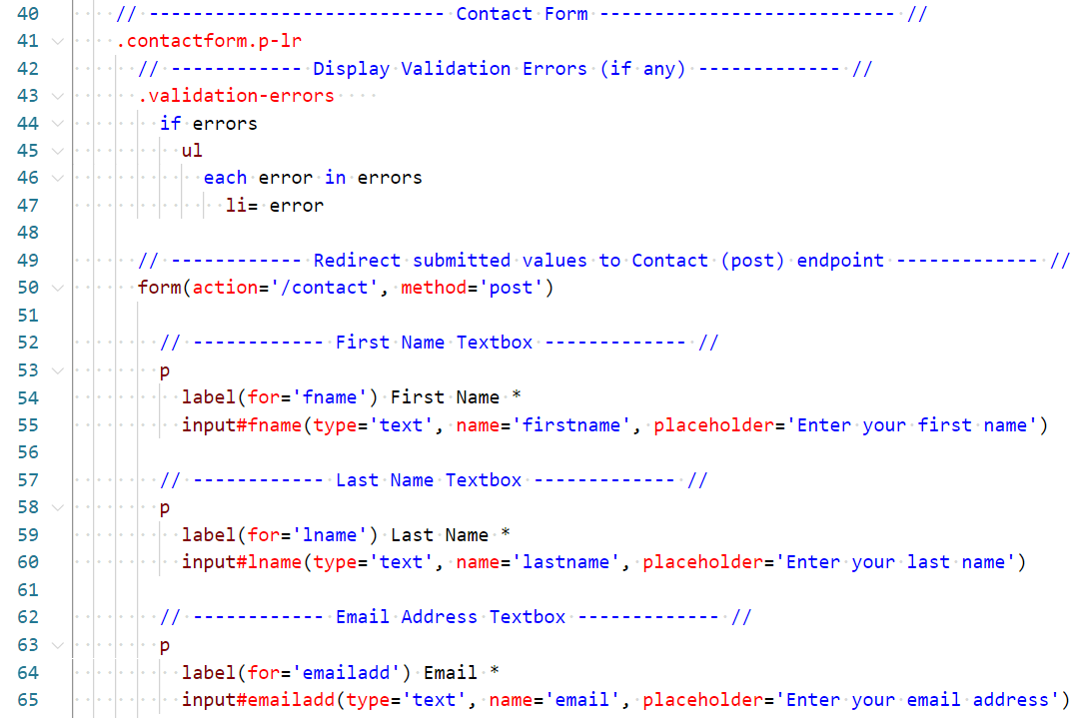

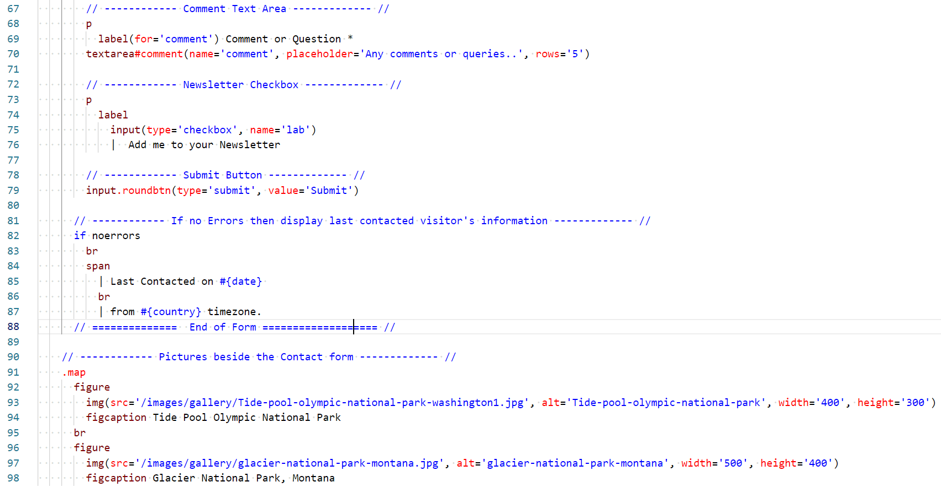

1. **REGISTER PAGE –** register.pug

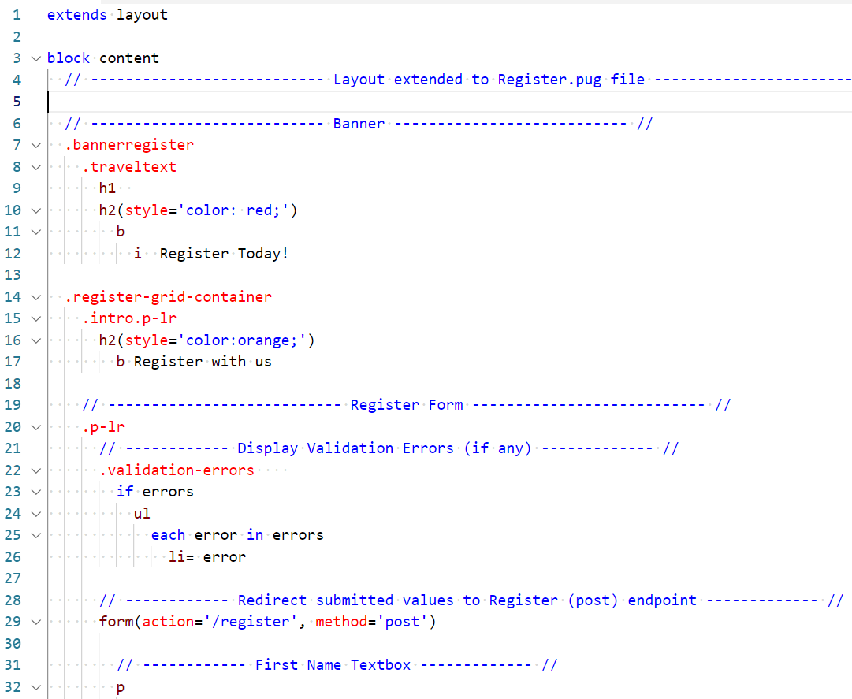

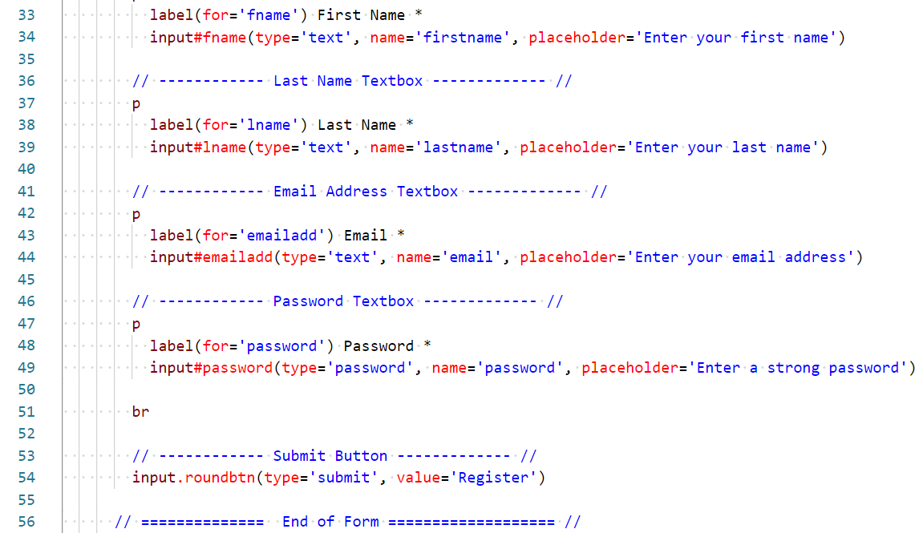

1. **ERROR PAGE –** Error.pug

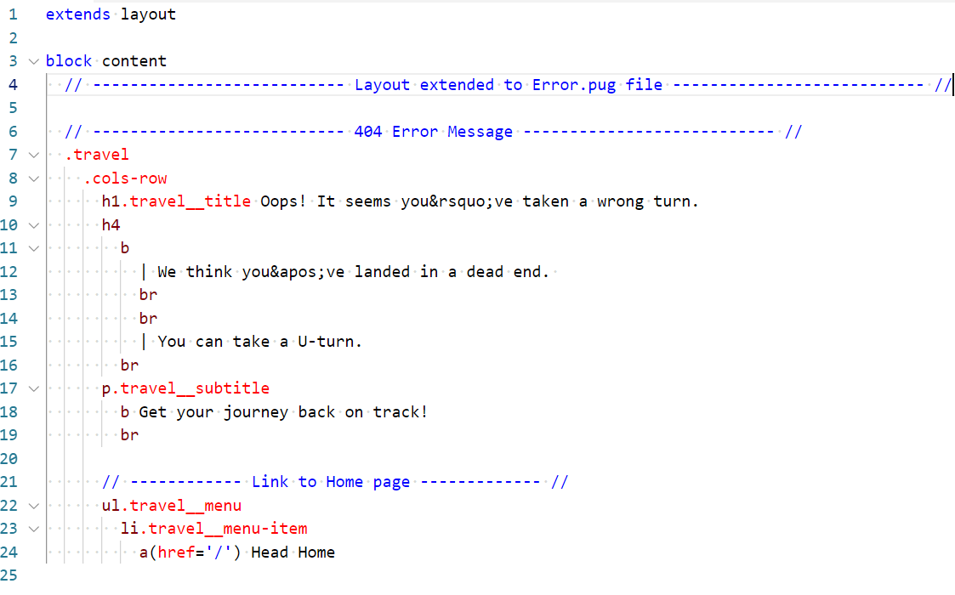

**A LAYOUT was created to extend it in all pug files – Layout.pug:**

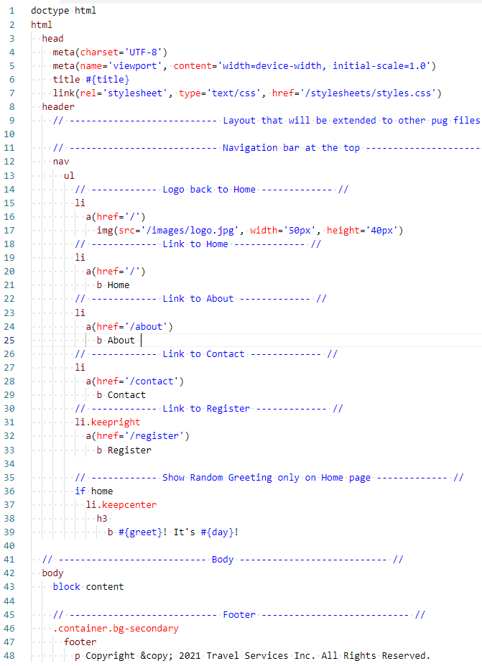

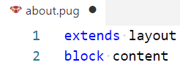  
All other pug files have utilized the layout as shown: 🡺

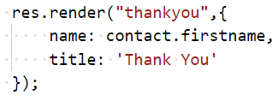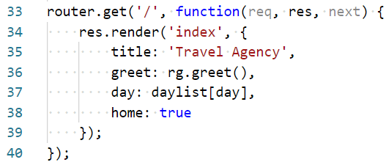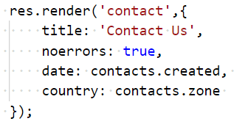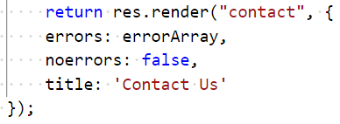The following **variables were used to pass into Pug templates**: Title, greetings, day, date, time zone, home, name, errors. The values stored in these variables are used to change information on the page:

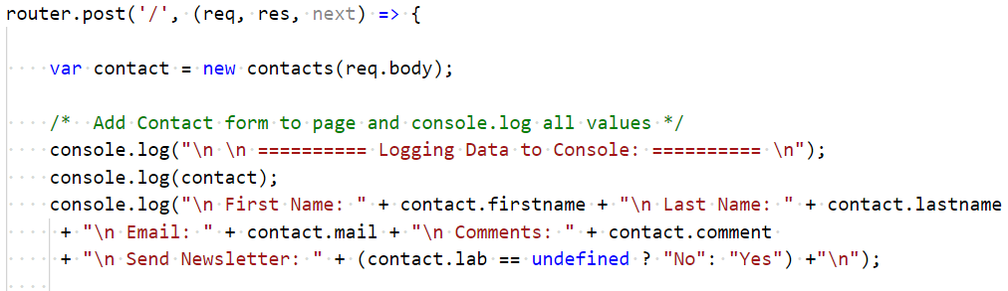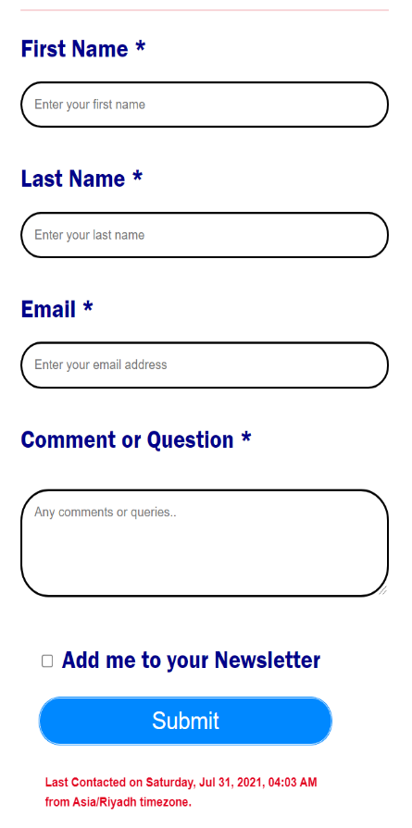  
**CONTACT FORM was added to Contact page and all values entered by the user were logged to console:**

**Upon submitting the Contact Form, user is redirected to a Thank You Page:**

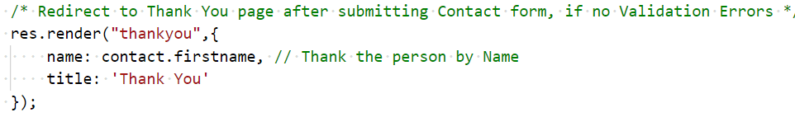

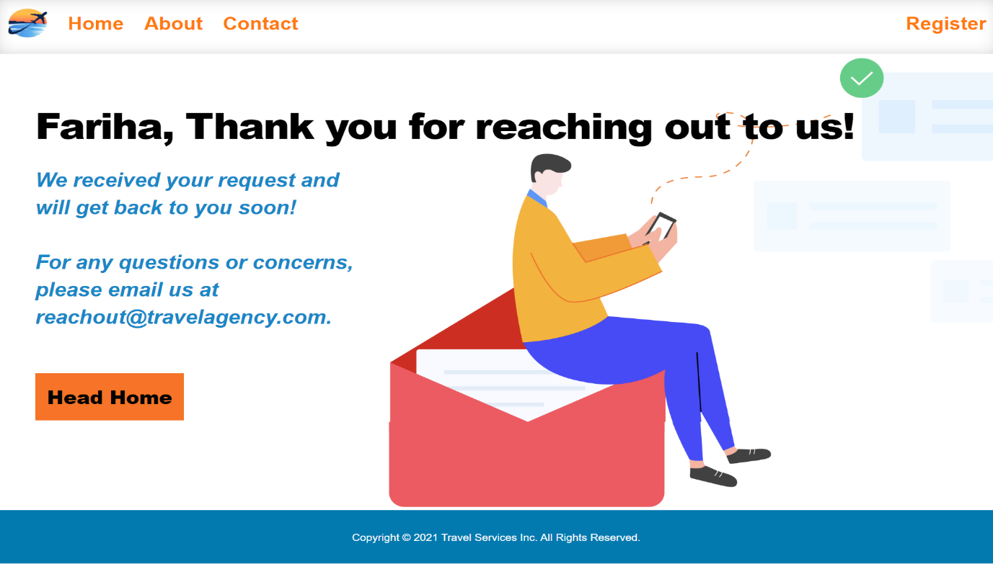

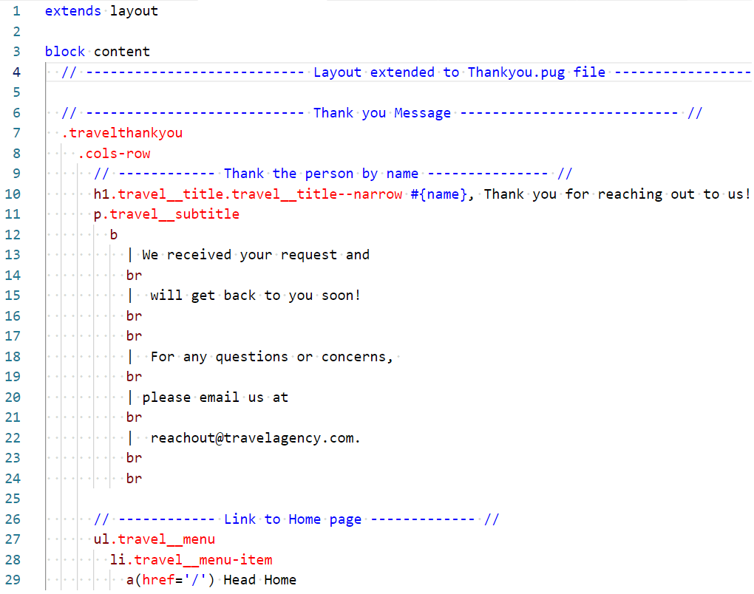

**ASSIGNMENT 5:**

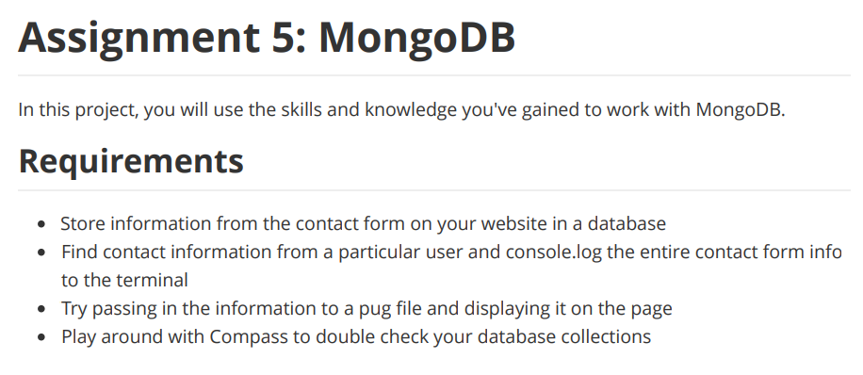

To achieve the above, install MongoDB and Mongoose package in your project:

1. Install MongoDB by entering the command in Terminal:  
    npm install mongodb
2. Install Mongoose by entering the command in Terminal:  
    npm install mongoose
3. Require the Mongoose module and utilize its functions as needed.

var mongoose = require('mongoose');

1. Setup a connection with your Database.

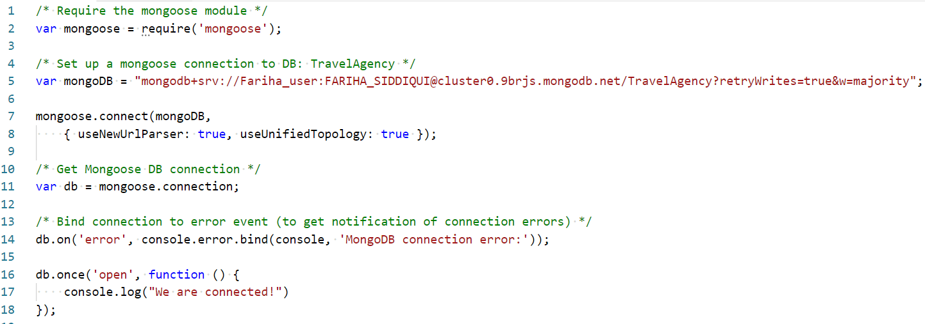

1. Define a Schema for Contacts.

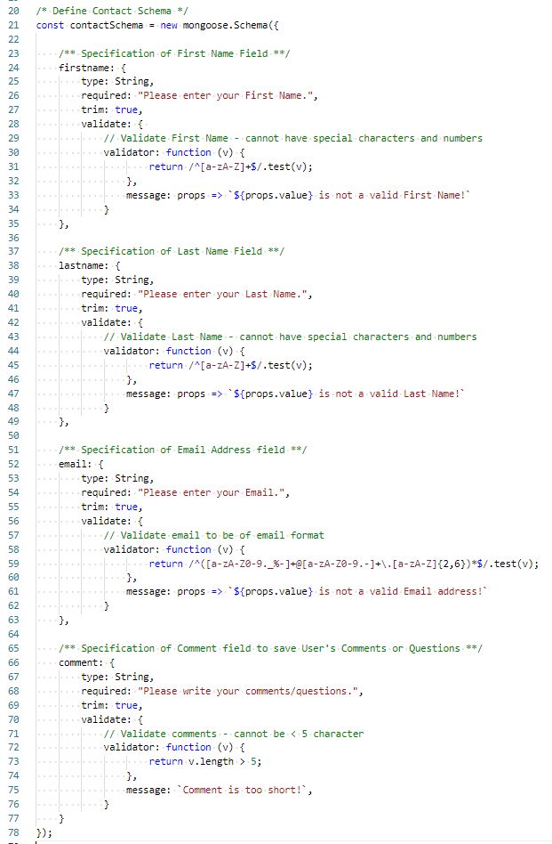

1. Save the created schema in DB, by using save() function.

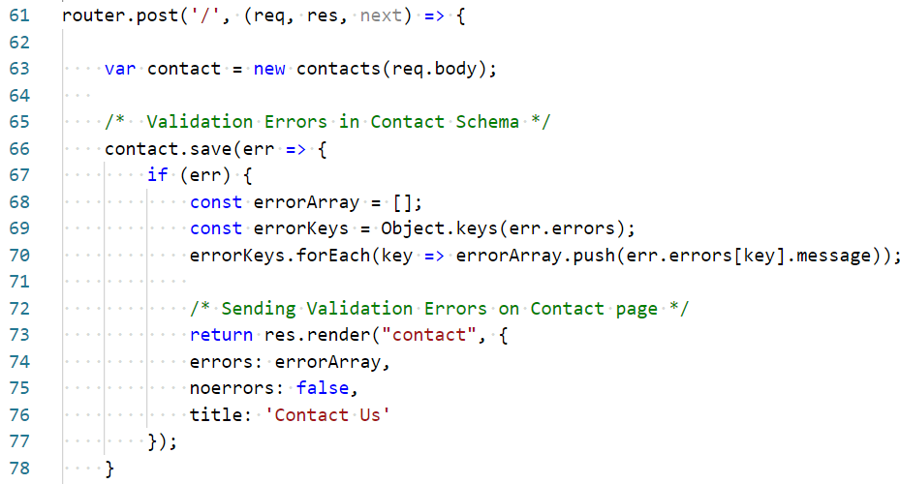

**Contact Information from the last contacted user was fetched and the entire contact information was logged to the Terminal.  
  
Also, information of last contacted user (date, time & time zone) was found from DB and passed to Contact.pug & displayed at the end of Contact page.**

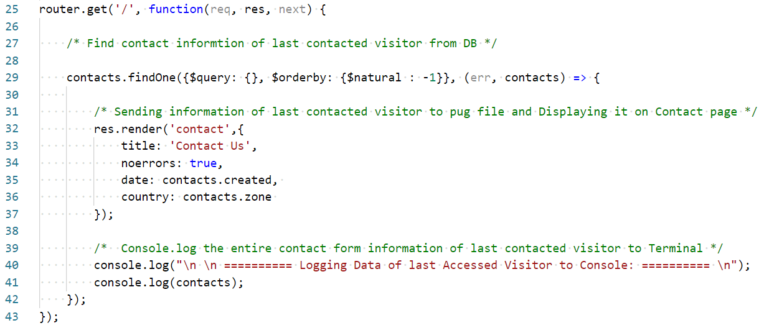

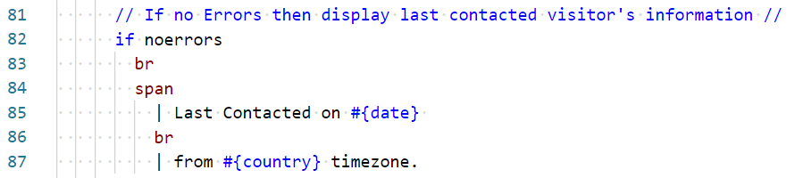

Date, Time & Time zone are fetched from DB, and displayed at the end of Contact form.

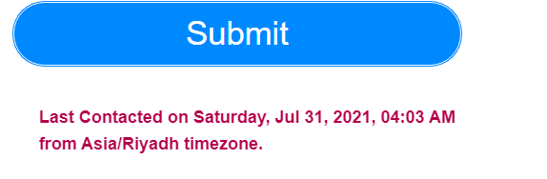

Database and Collections as saved in **MongoDB** **Compass:**

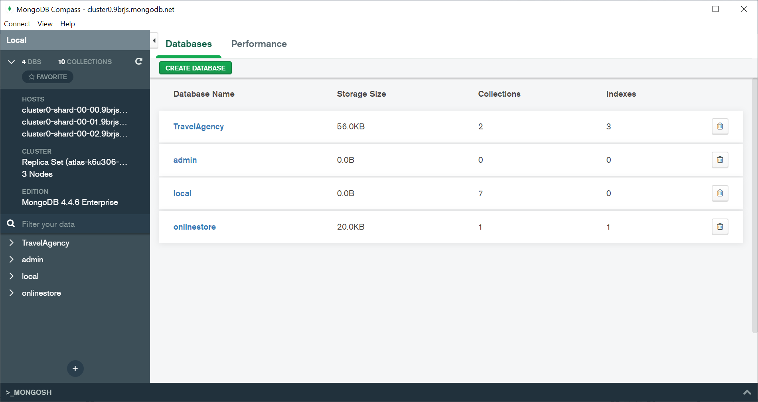

Database and Collections as saved in **MongoDB** **Atlas:**

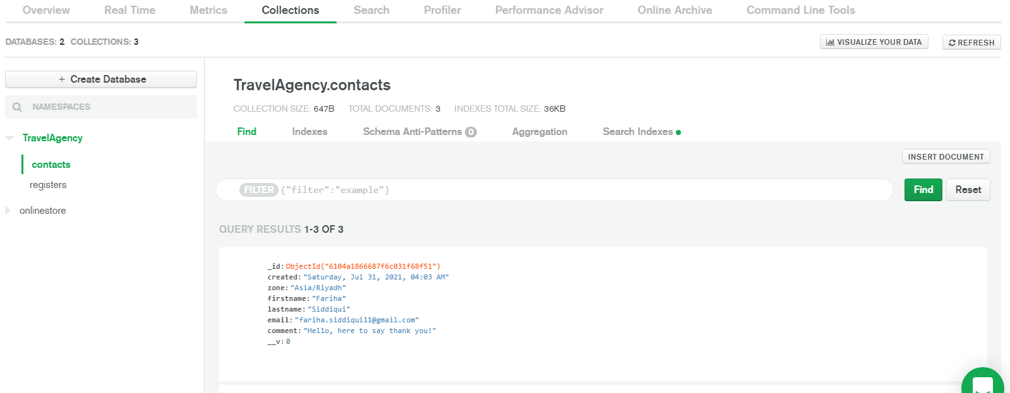

**ASSIGNMENT 6:**

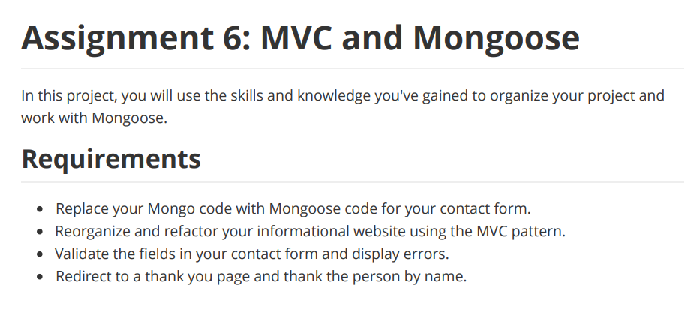

To achieve the above, the website was reorganized and refactored using MVC pattern.

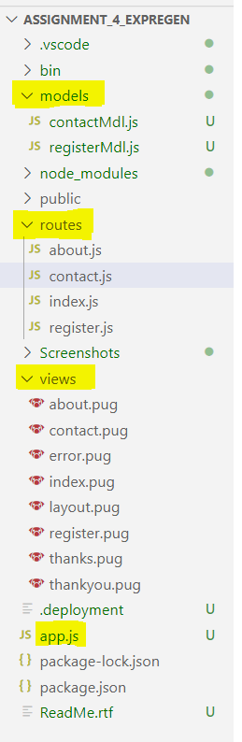**MVC** is a design pattern and is a popular architecture for applications, that helps us organize the code. It consists of:

* **Model** – Part of the application that deals with Database.
  + **“Models”** folder consisting of contactMdl and registerMdl act as the Model of the project.
* **View** – Part of the application that deals with everything that the user will see.
  + **“Views”** folder consisting of all pug files act as View of the project.
* **Controller** – The connector between Models & Views. Controller calls models to get data and then sends that data to the views, so that the user can see the data.
  + **“App.js”** & **“Routes”** folder consisting of JS files act as Controller of the project.

**Fields of Contact form & Registration form were validated & errors were displayed**

Mongoose unique validator has to be required first:

const uniqueValidator = require('mongoose-unique-validator');

Validate your Schemas using the unique Validator:

contactSchema.plugin(uniqueValidator);

registerSchema.plugin(uniqueValidator);



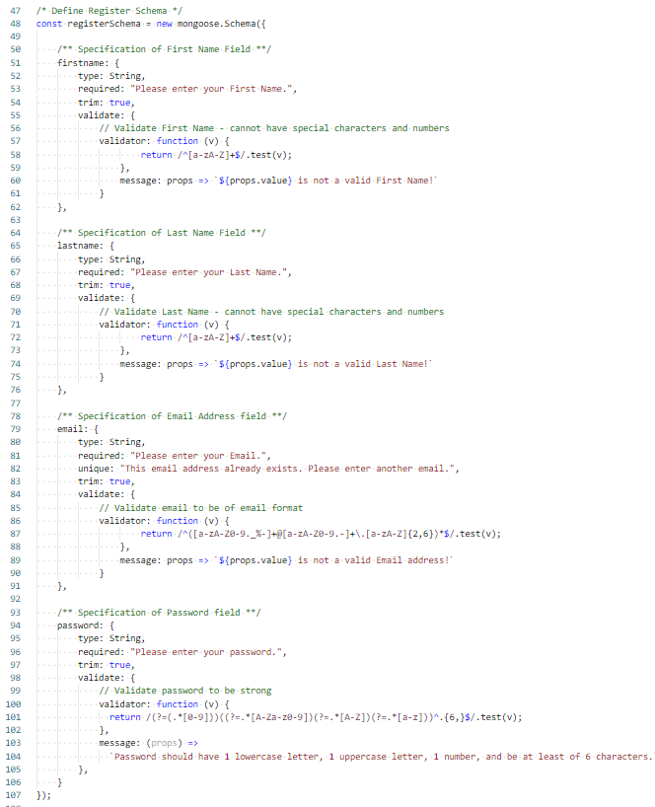

Validation Errors were passed to the pug files as shown below:

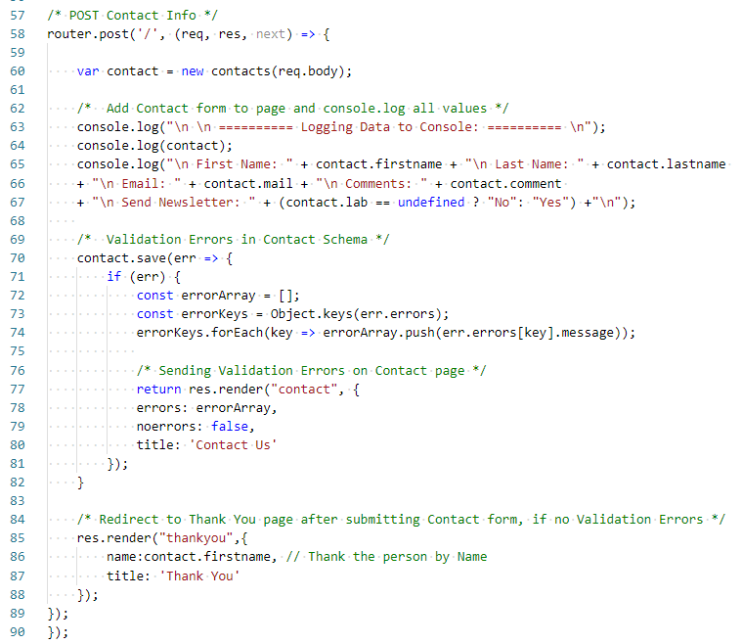

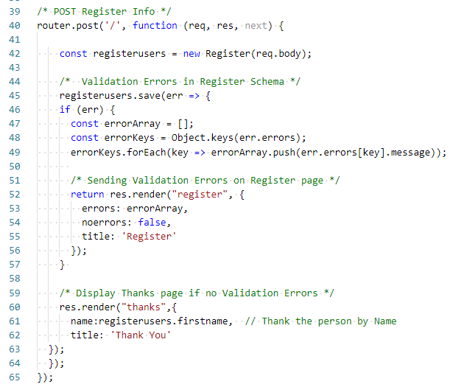

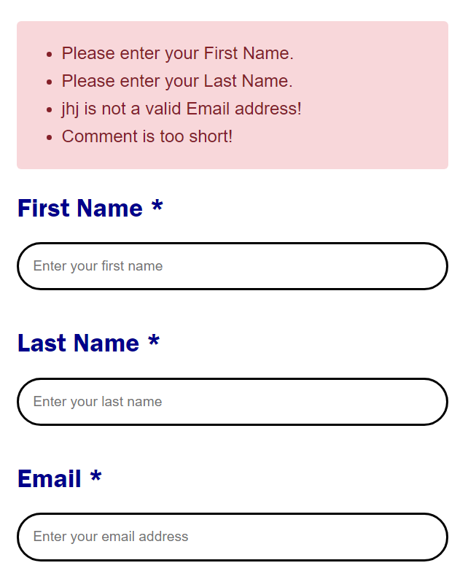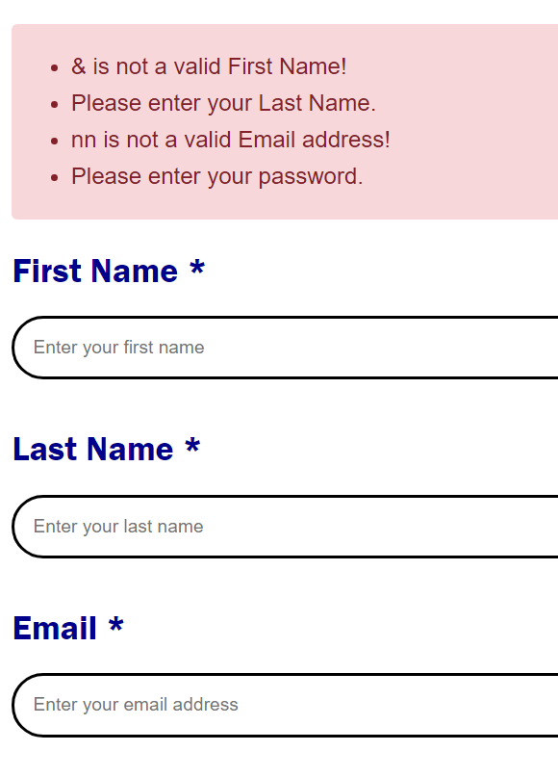Validation Errors were displayed on both Contact Form & Registration Form:

**CONTACT FORM**

**REGISTRATION FORM**

Values passed to pug files are used in the manner as shown below:

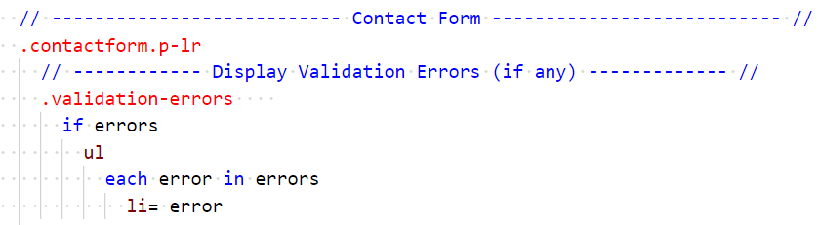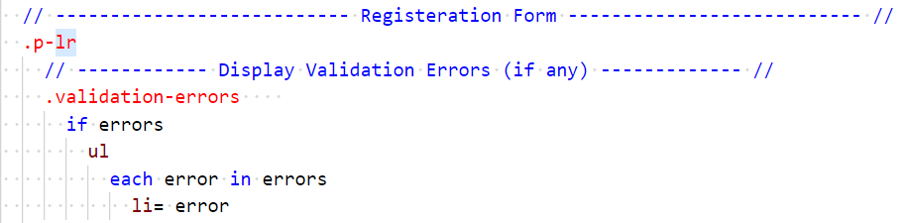

**After submitting the Contact Form & Registration Form, user is redirected to a Thank you page, where the user is thanked by name.**

**Contact Form**:

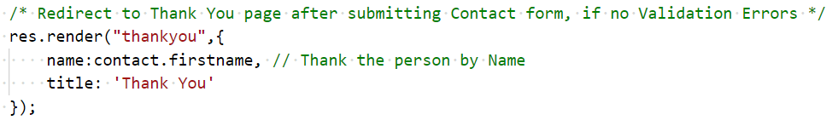

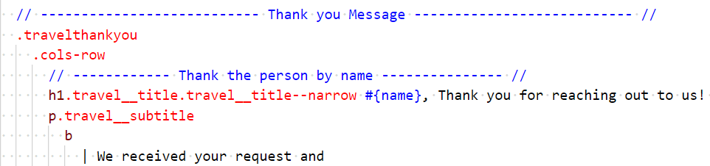

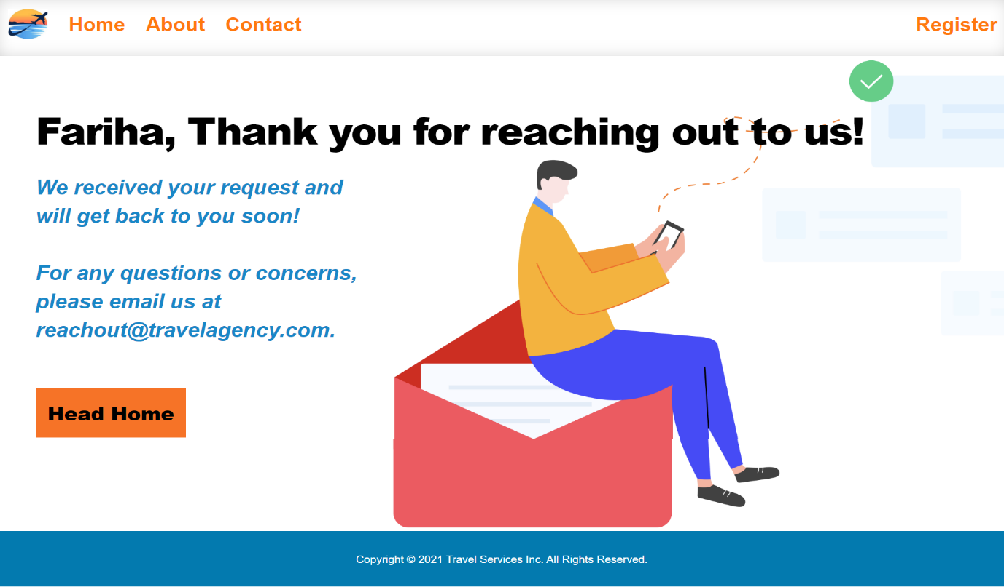

**Registration Form:**

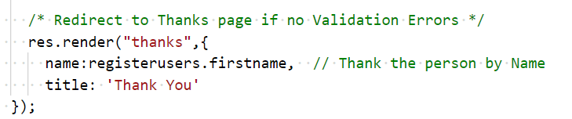

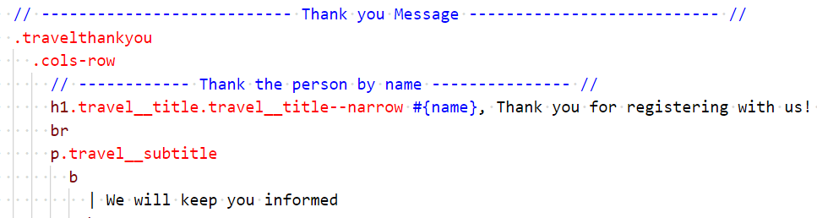

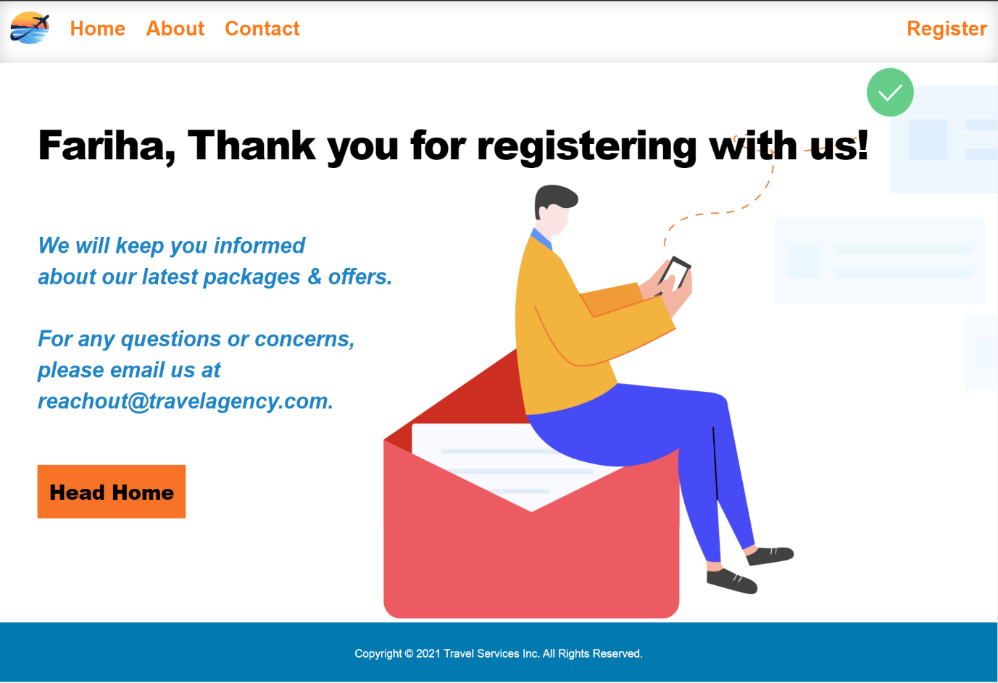

**GITHUB:**

This project consisting of all assignments has been posted on GitHub. URL is:

[**https://github.com/FariSid/TravelAgency.git**](https://github.com/FariSid/TravelAgency.git)

**AZURE:**

This project consisting of all assignments has been deployed on Azure. URL is:

[**https://farihatravelagency.azurewebsites.net/**](https://farihatravelagency.azurewebsites.net/)

**ZIP:**

This project consisting of all assignments has been zipped and can be accessed by clicking the below link:[**Download and install Node Modules. Then Run the code on Port 3300.**](https://drive.google.com/file/d/1LwMtiZNDGSJjQ3URs9vmjvq9vGjOxiRl/view?usp=sharing)